 | The New Method of Treatment  in Obstetrics & Gynecology

Intravaginal Continuous-Flow Insufflations of Ozone/Oxygen Gas Mixtures

Inflammatory diseases of female genital system including lower genital organs (colpitis, endocervicitis, bacterial vaginosis) are considered the most frequent pathologies of woman's body. The therapeutic approach we present here is intended for practical health service (gynecological and prenatal clinics or gynecological divisions of hospitals), is simple to perform and thus can be provided by any medical practitioner without special training.
In the above cases orthodox medicine can offer only treatment with antibiotics and antiseptic solutions, which are insufficiently effective and often induce considerable side-effects or adverse reactions (aggravating disturbances of vaginal microbiocenosis, allergic reactions).
After all, the antibiotics should not be used within a period of early pregnancy when the women of risk group related to intrauterine infection particularly need intravaginal cleansing irrigations. Besides, the actual microflora is resistant to most of the available antibiotics, thus there is a need for a new approach in the treatment of colpitis and bacterial vaginosis.
The new high-effective and safe approach in the treatment of acute, sub-acute and chronic inflammatory female genital diseases has been developed thanks to the new gynecological accessory set for intravaginal continuous-flow irrigations with O₂/O₃ gas mixtures. This method is safe, simple, clinically and economically effective.

Performance, Concentrations & Dosages

The treatment is carried out by means of the gynecological accessory set containing an intravaginal tip and a disposable vaginal catheter fastened onto the vaginal speculum. This method is absolutely safe for both the patient and medical practitioner.

Vaginal catheter
 | For this method vaginal speculum (usual or modified) should be used; before the treatment an intravaginal tip should be connected with a disposable vaginal catheter as demonstrated.
Intravaginal tip

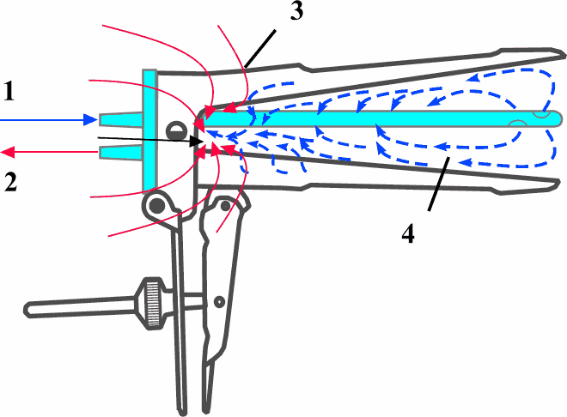  1. Delivery of O₂/O₃; 2. Removal of O₂/O₃  3. Vaginal Kusko speculum; 4. O₂/O₃ flow | The intravaginal tip previously fastened onto the vaginal speculum is constructed so that being connected via tubing with the pumping unit Medozons-UPM it reliably removes residual O₂/O₃ mixture thus providing an effective and safe treatment.  Direct application of gaseous ozone to the vagina provides the most complete contact of the therapeutic agent with vaginal epithelium.  In order to ensure complete removal of residual O₂/O₃ mixture it is important to choose the correct No. of vaginal speculum: if No. 1 is physiologically indicated, then use only this No.; for physiologically indicated No. 2 – use No. 2 or No. 1; for physiologically indicated No. 3 – use No. 3 or No. 2. It would be enough for you to order No. 1 and No. 2.

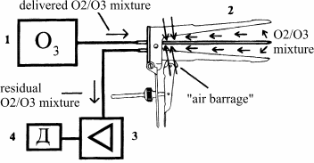 | Fig. 1. Functional schema of intravaginal continuous-flow treatment with O₂/O₃ gas mixtures:  - Medical ozone generator of Medozons series  - Vaginal speculum in construction with an intravaginal tip and a disposable vaginal catheter  - Multipurpose pumping unit Medozons-UPM  - Destructor for residual О₂/О₃ gas mixture.
The treatment should be performed in a gynecological chair; the vaginal speculum in complete construction should be inserted per vaginum.
- The inlet port of intravaginal tip should be connected via tubing with the medical ozone generator (O₂/O₃ flow is delivered at 0,5 - 1 L/min);
- The outlet port of intravaginal tip should be connected via tubing with the Medozons-UPM (removal of residual ozone to a catalytic destructor occurs at a flow rate of 3 - 5 L/min via the Medozons-UPM).
The treatment should be carried out daily for 5-8 days, ozone concentrations range from 3000 - 2000 mcg/L (1st treatment) to 2000 - 1000 mcg/L (follow-up treatments), duration of each treatment - 5 min.
Ozone concentrations within 1000 - 3000 mcg/L are the optimal ones to produce a bactericidal effect versus pathogenic coccal flora as well as yeast fungi without modifying the normal vaginal flora.
Before the treatment the area treated should be moistened with distilled or ozonized water. The best positive results have been obtained in case of using ozonized water fine dispersions that considerably improves a therapeutic effect of ozone in gas phase.
If indicated, a therapeutic effect at a local level can be improved through applications of high-quality ozonized olive oil O’THREE-Ozonide.
In order to administer a systemic effect of medical ozone, intravaginal ozone insufflations can be performed in combination with rectal ozone insufflations by means of the multipurpose accessory set Medozons-Set.

The Gynecological Accessory Set for intravaginal continuous-flow insufflations with O₂/O₃ gas mixtures can be successfully used with each model of medical ozone generators of Medozons series !

Owing to the powerful therapeutic properties of medical ozone it becomes possible to reject the use of antibiotics and antiseptic solutions, which can modify the normal vaginal flora. Medical ozone applications are effective, simple and do not cause any side-effects.
Intravaginal continuous-flow treatment with O₂/O₃ gas mixtures has shown the following laboratory results:
- normalization of local immunity factors in vaginal secretion;
- elimination of pathogenic and opportunistic microorganisms (valid through bacterioscopy);
- a considerable decrease in the colonization and an increase in the sensitivity to antibiotics.
This kind of treatment yields remarkable clinical improvements in all patients with above pathologies – elimination or a decrease in pathological secretions, decreased feeling of discomfort.

Recommendations:

- Owing to the highly disinfectant properties of ozone as well as its beneficial effect on the microcirculation in the tissues and on the immunity intravaginal continuous-flow insufflation with O₂/O₃ gas mixtures is a promising therapeutic approach allowing reducing drug consumption and rejecting the use of antiseptic solutions.
- The above method of ozone therapy is indicated in the treatment of non-specific colpitis and bacterial vaginosis. There are no contraindications. This approach is clinically tested.

Comparative effectiveness of intravaginal ozone applications
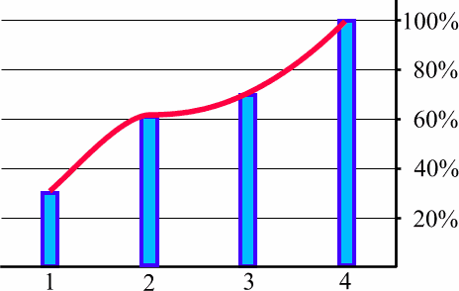 | 1. Instillations of ozonized distilled water;  2. Continuous-flow insufflations of ozonized distilled water fine dispersions;  3. Continuous-flow insufflations of O₂/O₃ gas mixtures after having moistened the area treated with ozonized distilled water;  4. Continuous-flow insufflations of O₂/O₃ gas mixtures in combination with ozonized distilled water fine dispersions (a combination of methods 2 and 3).
Methods of application

Conclusion.
Intravaginal ozone applications are successfully used in the treatment of the most frequent inflammatory diseases of lower female genital organs (colpitis, bacterial vaginosis). The above methods are intended for ambulant gynecological and prenatal clinics, are simple to perform and can be provided by any medical practitioner without special training.

MEDOZONS LTD. ∗ Ul. B.Panina 9 ∗ 603089 Nizhny Novgorod / Russia
Tel.: +7-8312/167 067 ∗ Fax: +7-8312/167 000 ∗ E-Mail: export@medozons.ru ∗ Internet: http://www.medozons.ru/eng

